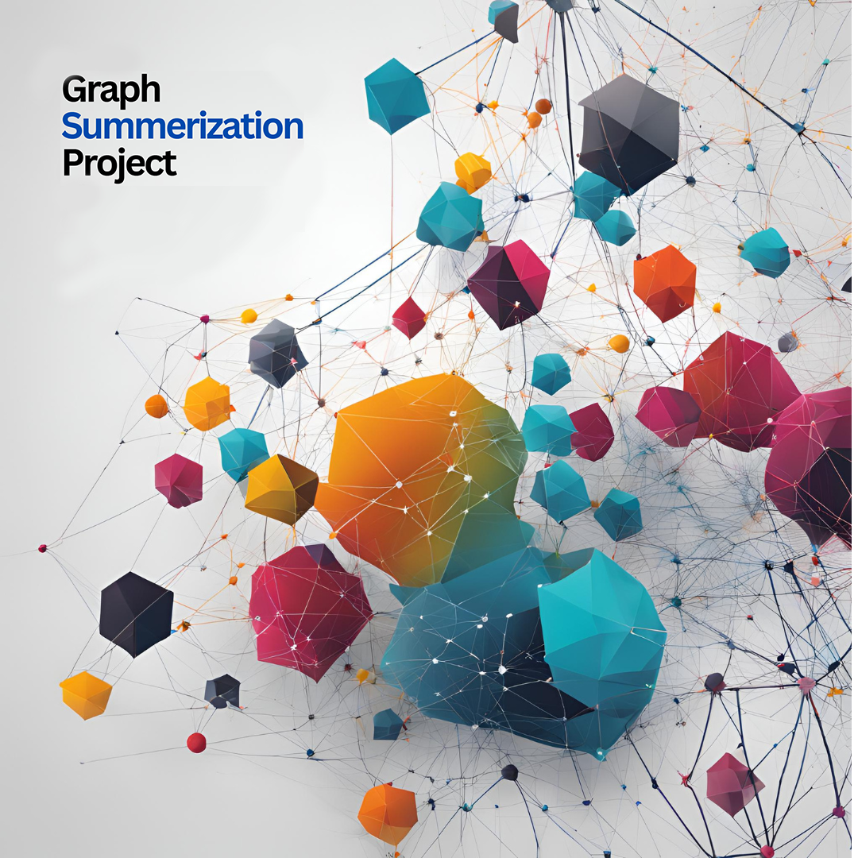

Algorithm and Complexity Project
Graph Summarization Algorithm Design
Maintaining Influential nodes

[Project Members]
Abdulrahman Alkhatib, 441015203
Omar Osama, 441023643
Yasir Fatimi, 441024553
Mashhoor Shakip, 441023683

Instructor
Dr. Waqas Nawas

Table of Content
Table of Content 1
1. Introduction 3
2. Related Work: 4
2.1 A Hierarchical Parallel Graph Summarization Approach Based on Ranking Nodes Problem Liu, Qiang, et al. 2023 (1) 4
2.1.1 Application of HRNS Concepts in Our Algorithm 4
2.1.2 Enhancements Over HRNS 4
2.2 VEGAS: Visual Influence Graph Summarization on Citation Networks
L. Shi, et al. 2015 (2) 5
2.2.1 Application of VEGAS Concepts in Our Algorithm 5
2.2.2 Enhancements and Integration with Our Work 5
3. Algorithm Description 6
3.1 Hybrid Weighted Importance 6
3.2 Node Merging Strategy (Enhancement) 7
Original Methodology 7
Enhanced Strategy 7
Formula: 7
Explanation 7
3.3 Node Importance Combination 7
3.4 Algorithm Steps 8
4. Complexity Analysis 9
4.1 Time Complexity 9
4.2 Space Complexity 9
5. Theoretical Evaluation 10
5.1 Correctness 10
5.2 Advantages & Limitations 10
5.3 Applicability 11
5.3.1 Undirected Graphs 11
5.3.2 Directed Graphs 11
5.3.3 Weighted Graphs 11
5.3.4 Sparse Graphs 11
5.3.6 Planar Graphs – Figure [1] 11
5.3.7 Hypergraphs – Figure [2] 11
6. Discussion 12
7. Conclusion 12
8. References 13

1. Introduction
In the field of network analysis, one of the biggest challenges is keeping important information while reducing the size of a graph. When the graph is made smaller, some important nodes or connections may be lost, which are essential for understanding how the network is structured. This issue is especially important in areas like social network analysis, community detection, biological networks, and communication networks, where central nodes play a key role in the overall function of the network.
To keep this important information, summarization algorithms must be able to identify the most important nodes and maintain their connections. Many traditional graph summarization algorithms mainly rely on basic measurements such as degree centrality and edge weight, which limits their ability to capture nodes that act as important connections between different parts of the network or help with the flow of information.
The algorithm proposed in this study aims to improve this process by including different centrality measures, such as betweenness centrality, closeness centrality, and community linkage, along with specific metrics for the application, to more accurately measure the importance of nodes. This method offers a more complete summary of the graph, better showing the true behavior of the network and ensuring that the most important nodes are kept.
The main goal of the proposed algorithm is to improve the accuracy of graph summarization by focusing on keeping nodes that are crucial to the network's structure. Unlike traditional algorithms that only rely on basic measurements, this algorithm looks at more factors of node importance by combining multiple centrality measures and how they work together.
It is expected that this algorithm will lead to better performance in various real-world applications, such as improving social network recommendations, enhancing network analysis, and getting more accurate results in community detection.

2. Related Work:

2.1 A Hierarchical Parallel Graph Summarization Approach Based on Ranking Nodes Problem Liu, Qiang, et al. 2023 (1)
Traditional graph summarization techniques aim to reduce the storage size of large graphs, often leveraging Minimum Description Length (MDL) principles. However, these methods face challenges such as limited summarization dimensions, overlooking diverse graph properties, low efficiency with scalability issues, and an inability to retain key node characteristics, where important nodes may be prematurely merged, leading to information loss.
The paper introduces HRNS (Hierarchical Parallel Graph Summarization) to address these limitations. It ranks nodes based on hybrid weighted importance, combining various centrality metrics like degree, closeness, and betweenness with customizable weights. This ranking is integrated into the MDL framework, enhancing the summarization process by considering node importance. Additionally, HRNS employs hierarchical parallel processing to accelerate graph summarization while maintaining low error rates.

2.1.1 Application of HRNS Concepts in Our Algorithm
Our algorithm builds on HRNS by adopting and enhancing several key components. The hybrid weighted strategy for node importance calculation is integrated, combining multiple centrality metrics with customizable weights to improve accuracy in identifying critical nodes. A priority queue is implemented for node pairing, optimizing the selection of high-priority pairs for merging, inspired by HRNS’s method of ranking node pairs based on merging scores. The algorithm follows an iterative merging process, continuously merging nodes based on their importance until the desired graph size is achieved. Parallel processing is incorporated to improve computational efficiency, particularly for large-scale graphs.

2.1.2 Enhancements Over HRNS
While HRNS provides a robust framework, our algorithm introduces several enhancements. Scalability is improved by optimizing the parallel processing framework and balancing the load across partitions, enabling better performance on large and dense graphs. The weighting mechanism for node importance is made more flexible and dynamic, adapting to specific graph characteristics and application requirements. Additionally, our approach enhances accuracy in retaining key nodes, reducing information loss and preserving critical structural and semantic properties. This integration of HRNS concepts, combined with our enhancements, results in a more efficient, scalable, and accurate graph summarization algorithm that balances storage efficiency with the preservation of essential graph characteristics.

2.2 VEGAS: Visual Influence Graph Summarization on Citation Networks
L. Shi, et al. 2015 (2)
Summarizing large citation networks while maintaining influence patterns and readability is challenging. Existing methods either focus on detecting influential nodes without summarizing the graph or simplify the graph at the cost of losing hidden influence flows.
The authors introduce the Influence Graph Summarization (IGS) problem, which they solve using a matrix decomposition-based algorithm pipeline. This approach highlights flow-based influence patterns, supports rich attribute data, and achieves localized visual summarization. VEGAS, the system implementing this pipeline, balances visualization clarity, optimization quality, and computational efficiency.

2.2.1 Application of VEGAS Concepts in Our Algorithm
Although VEGAS emphasizes flow-based influence patterns and visualization, aspects of its approach align with our algorithm. Similar to VEGAS, we initialize the graph and necessary data structures for computation. The focus on centrality and influence patterns resonates with our hybrid weighted importance strategy, where we combine centrality metrics to calculate node importance. For priority queue initialization and node merging, our method prioritizes merging node pairs based on their score, similar to VEGAS’s clustering and summarization approach aimed at efficiently identifying and processing key nodes. Both methods aim to output a simplified yet meaningful graph that preserves essential structural and influential characteristics.

2.2.2 Enhancements and Integration with Our Work
We integrate VEGAS’s concepts related to node importance calculation, as their emphasis on centrality aligns with our use of weighted centrality metrics. However, our approach does not incorporate flow-based influence patterns or visualization, which are core to VEGAS’s system. By building on their methods for identifying influential nodes, we enhance our graph summarization algorithm with improved node merging processes, effectively prioritizing critical nodes and preserving key structural properties.

3. Algorithm Description

3.1 Hybrid Weighted Importance
This part enhances the calculation of a node's importance by incorporating multiple centrality metrics, making the importance measure more comprehensive. The original algorithm considered only basic metrics.
Original Formula:
Ii = ∑^{n}_{(j=0)} (mi,j × wj)

· This formula calculates the importance I_{i} of each node i.
  - m I ,j​: Represents a specific metric for node i.
  - w j: Weight for that metric.
· Note: It uses only basic metrics like degree and edge weight.

Enhanced formula
Ii = w1×DegreeCentrality + w2×BetweennessCentrality +
w3×Closeness Centrality + w4×Community Centrality + w5×Domain-Specific Metric

w1 , w2 , w3 , w4 : Weights assigned to each metric based on its relevance.

Degree Centrality: This measures the number of direct connections a node has. A higher degree centrality indicates a node with many direct links, it's important because it can directly influence many other nodes.

Betweenness Centrality: This measures how often a node appears on the paths between other nodes. A node with high betweenness centrality acts as a bridge, facilitating communication between different parts of the network.

Closeness Centrality: This measures how close a node is to all other nodes in the network. A node with high closeness centrality can quickly interact with others, making it crucial for spreading information.

Community Centrality: This evaluates a node's role in connecting different clusters or communities within the graph. Nodes with high community centrality are important for maintaining the network's structural integrity.

Domain-Specific Metric: This is a custom metric tailored to the specific application domain. It adds flexibility to the algorithm, allowing for the inclusion of specialized importance measures relevant to the particular context.

3.2 Node Merging Strategy (Enhancement)
The node merging strategy in original HRNS algorithm is based on minimizing edge storage overhead, we enhanced it by converting node importance into the merging decision, The merging priority for two nodes u and v is calculated as:

Original Methodology
Focused on minimizing edge storage overhead by merging nodes based on structural properties.

Enhanced Strategy
We incorporate node importance into merging decisions.

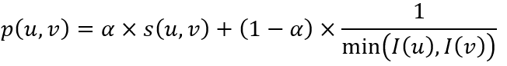
Formula:

  - p(u,v): Priority score for merging nodes u and v.
  - s(u,v): Edge cost reduction from merging nodes u and v.
  - I(u),I(v) : Importance scores of nodes u and v.
  - α alpha: Balances structural efficiency s(u,v) and importance preservation.

Explanation
The formula ensures that merging:
  - Reduces storage overhead s(u,v).
  - Preserves important nodes I(u),I(v).
Example:
  - Nodes A and B have scores I(A) = 10, I(B) = 20 , and merging them reduces edge costs by 5.
  - With α = 0.6
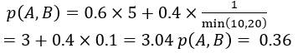
  - The priority score is:

3.3 Node Importance Combination
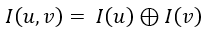
Combines the importance factor I (u, v) for the node pair using a customizable operator (⊕):

When evaluating the combined importance of a pair of nodes (I(u,v)), the algorithm uses a customizable operator (⊕). This operator can be tailored based on specific node-ranking scenarios:
Summation (⊕ = +): Aggregates the importance of scores
Example: I(A) = 10, I(B) = 20 → I(A, B) = 10 + 20 = 30
Maximum (⊕ = max): Retains the highest importance score between the two nodes, focusing on preserving the more significant node takes the higher score.
Example: I(A) = 10, I(B) = 20 → I(A, B) = 20
Weighted Average: Combines the importance scores based on a weighted average, allowing for a nuanced evaluation that reflects individual significance, Gives higher importance to more significant nodes.
Example: I(A) = 10, I(B) = 20, wA = 0.4, wB = 0.6
I(A, B) = 0.4 * 10 + 0.6 * 20 = 16

3.4 Algorithm Steps
Firstly, we take the dense graph and then load the graph G = (V, E) and initialize above mentioned data structures, Secondly, the Node Importance Calculation come in to compute the importance score I(u) for each node based on the weighted combination of centrality metrics and then, Thirdly, we prioritize the nodes by queue system by inserting all possible node pairs (u, v) into a priority queue, prioritize their merging score p(u, v) and then, Fourthly, we do node merging iteratively merging node pairs with the highest priority until we reached to the summarized graph size, Fifthly, the output summarized graph will be generated with the retained nodes and edges.

4. Complexity Analysis

4.1 Time Complexity
Calculating centralities:
- Degree Centrality: O(V + E)
- Closeness Centrality: O(V × (V + E))
- Betweenness Centrality: O(V × E + V²logV)
Complexity of merging nodes using Two-hop strategy:
O(V × Δ² + ElogE)
(where Δ is the maximum node degree)
overall avg time complexity of our enhanced algorithm is:
For Dense Graphs when (E ≈ V):
O(V × (V + E) + V × Δ² + ElogE)
or (E ≈ V): O(V²logV)

4.2 Space Complexity
Centralities Space Complexity:
- Degree Centrality: O(|V|)
- Closeness Centrality: Adjacency List O(V + E)
- Betweenness Centrality: Adjacency List O(V + E)
In total of storage for weights and importance factors:
O(|V| × k)
(where k is the number of metrics "e.g. degree, closeness, betweenness)
Space Complexity of using Two-hop merging strategy:
O(V × Δ²)
(where Δ is the maximum node degree)
overall space complexity of our enhanced algorithm is:
For Dense Graphs when (E ≈ V):
O(V² + V² + V× V²) ≈ O(V ³)

5. Theoretical Evaluation

5.1 Correctness
In our Correctness section I want to mention that the Node Importance Calculation using hybrid weighted importance correctly integrates multiple centrality measures (e.g. degree centrality, betweenness.. etc) and putting it in terms of a single importance score, ensuring that
- nodes are highly connected (degree) are prioritized, and nodes critical for communication between clusters (betweenness) are recognized, and nodes that can quickly access other nodes (closeness) are considered
This corrects a potential bias of traditional approaches that may only consider degree centrality like the one in HRNS algorithm.
- Two-Hop Merging Strategy
The merging strategy balances structural efficiency and importance preservation using a tunable parameter , it ensures that High-cost reductions (based on edge cost) are prioritized to minimize graph complexity, and Important nodes are retained to preserve critical graph information.

5.2 Advantages & Limitations
Advantages |  | Limitations
1. Improved Importance Assessment | - By providing multiple centrality measures | 1. Complexity of Centrality Calculations | - Computing some centralities measures can be computationally expensive
2. Customization and Flexibility | - The tunable parameter α balances storage and retaining key information  - The merging operator ⊕ customized based on merging scenario | 2. Parameter Sensitivity | - The performance of the algorithm heavily depends on weights & α choices
3. Efficiency in Large Graphs | - Two-hop strategy reduces search space for merging in large graphs  - Parallel processing can be integrated into the framework to further accelerate performance | 3. Loss of Minor Informations | - As the algorithm prioritizing nodes, the less important nodes will be lost, and their connection will be dismissed too

5.3 Applicability
Applicable

5.3.1 Undirected Graphs
Highly Applicable, as the algorithm designed to summarize node importance and reduce edge cost without considering directionality.

5.3.2 Directed Graphs
Applicable with minor adjustments because of using multiple important metrics like betweenness and closeness the account for directionality.

5.3.3 Weighted Graphs
Highly Applicable, as the edge weights can represent the cost, capacity, and importance of connections, which can be incorporated into the edge cost reduction strategy.

5.3.4 Sparse Graphs
Highly Applicable, because of fewer edges to nodes the sparse have, our algorithm efficient in summarizing and identifying critical nodes and connections.

Less Applicable

5.3.6 Planar Graphs – Figure [1]
In scenarios where planar properties are essential (e.g. geographical maps) merging nodes might break planarity, making the algorithm less applicable.

5.3.7 Hypergraphs – Figure [2]
Since hypergraphs have edges connecting multiple nodes, the traditional Two-hop merging strategy may not directly apply on such graphs.
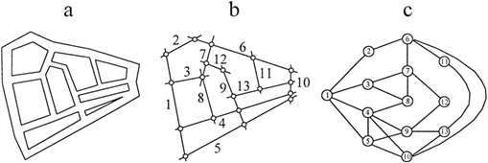
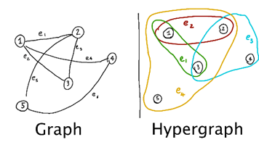

6. Discussion
The proposed enhancements to the hierarchical parallel graph summarization algorithm (HRNS) significantly improve its accuracy, adaptability, and efficiency in handling complex graph structures. Key improvements include enhanced node ranking system, which now the hybrid weighted importance approach now integrates multiple centrality metrics (e.g. degree, betweenness, closeness, and community linkage) to provide a more comprehensive assessment of node significance. This ensures that both local and global graph properties are considered, improving the retention of critical nodes during summarization also flexible importance aggregation for combination customizable aggregation operator (⊕) has been introduced to combine node importance during the merging phase. This flexibility allows the algorithm to adapt to various application requirements by prioritizing either cumulative influence, maximum importance, or a balanced average of merged nodes, and the use of optimized two-hop merging strategy which now incorporates a tunable parameter (α) to balance edge cost reduction and importance preservation. This optimization enables users to prioritize either storage efficiency or information retention, making the algorithm versatile across different domains.
Improved performance of the HRNS algorithm which demonstrates superior performance compared to traditional methods, with higher retention of key nodes, preserving essential structural and functional properties. lower error ratios, leading to more accurate graph summaries, and increased computational efficiency, enabling scalability to large, real-world datasets.

7. Conclusion
The enhancements introduced to the HRNS algorithm significantly improve its accuracy, adaptability, and computational efficiency. By integrating multiple centrality measures, the node-ranking process provides more holistic assessment of node importance, ensuring that both local and global graph properties are preserved.
Additionally, the optimized two-hop merging strategy incorporates a tunable parameter α to effectively balance storage efficiency with the retention of critical information. This reduces the likelihood of merging important nodes prematurely, leading to more accurate graph summaries with lower error ratios.
Finally, the enhanced HRNS algorithm demonstrates improved computational efficiency, achieving significant speedups over traditional methods. This scalability makes it well-suited for handling large-scale graph datasets across various domains, ensuring that the algorithm remains both practical and efficient for real-world applications.

8. References
[1] Liu, Q.; Wei, J.; Liu, H.; Ji, Y. A Hierarchical Parallel Graph Summarization Approach Based on Ranking Nodes. Appl. Sci. 2023, 13, 4664. https://doi.org/10.3390/app13084664
[2] L. Shi, H. Tong, J. Tang and C. Lin, "VEGAS: Visual influEnce GrAph Summarization on Citation Networks," in IEEE Transactions on Knowledge and Data Engineering, vol. 27, no. 12, pp. 3417-3431, 1 Dec. 2015, doi: 10.1109/TKDE.2015.2453957.
https://ieeexplore-ieee-org.sdl.idm.oclc.org/stamp/stamp.jsp?tp=&arnumber=7152908&isnumber=7317845

